**Drug Performance Analysis**

**Abstract:**

The Drug Performance Analysis DBMS project aims to design and develop a system that can effectively manage data related to drugs, patients, doctors, prescriptions, side effects, and treatments. The system will provide a user-friendly interface for doctors and medical professionals to input and retrieve data related to drug performance analysis. The system will track the prescriptions issued to patients, side effects experienced by patients, and treatments provided to patients. The system will be able to generate reports and insights on drug performance analysis based on the data collected, ultimately helping medical professionals make informed decisions about prescribing drugs and managing patient health.

**List of Tables:**

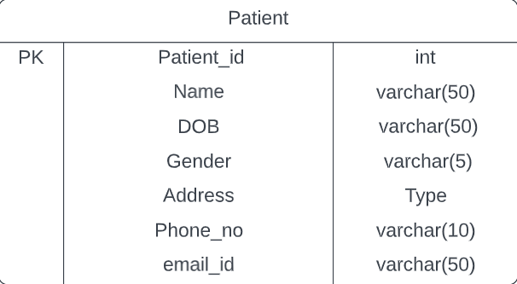 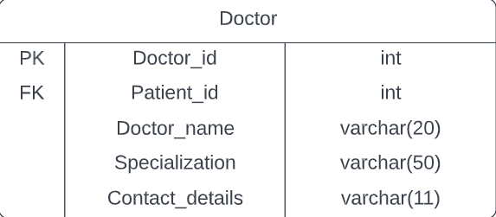

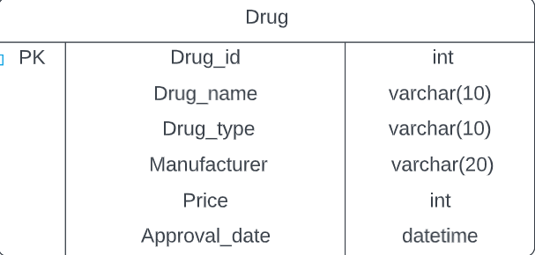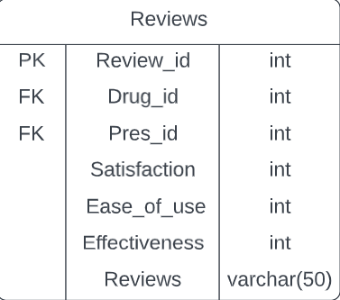 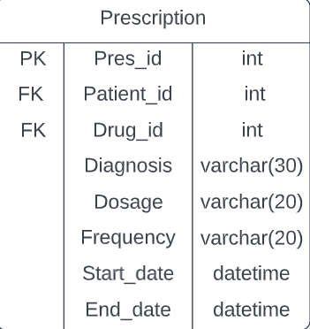 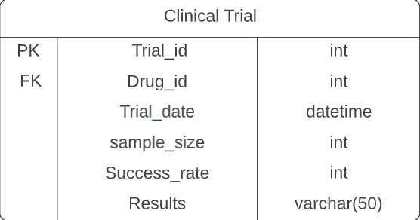

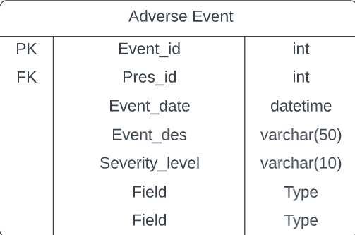

Mapping cardinalities:

* One doctor can have zero to many patients. (1:N)
* One patient can have zero to many prescriptions. (1:N)
* One drug can have zero to many prescriptions. (1:N)
* One drug can have zero to many clinical trials. (1:N)
* One drug can have zero to many reviews. (1:N)
* One prescription can have zero to many adverse events. (1:N)

ER Diagram:

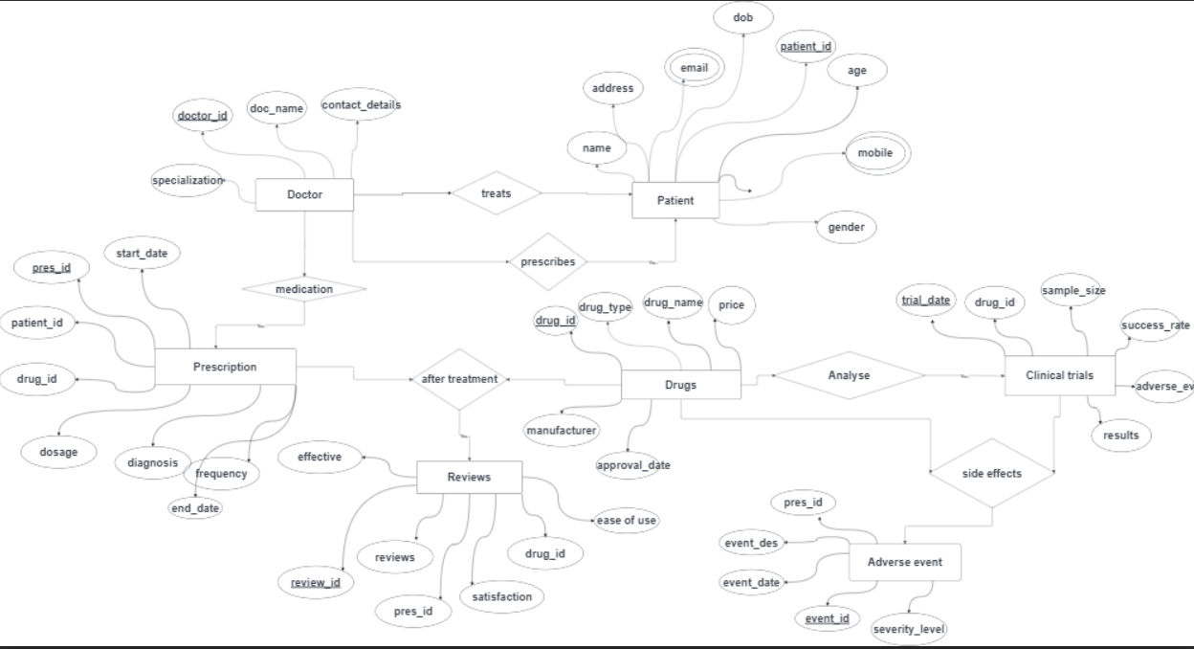

DDL Operations:

1.Patient Table:

CREATE TABLE Patient (

patient_id INT PRIMARY KEY,

name VARCHAR(50) NOT NULL,

date_of_birth DATE NOT NULL,

gender CHAR(1) NOT NULL,

address VARCHAR(100),

phone_number VARCHAR(20),

email VARCHAR(50)

);

2. Doctor Table:

CREATE TABLE Doctor (

doctor_id INT PRIMARY KEY,

doctor_name VARCHAR(50) NOT NULL,

specialization VARCHAR(50) NOT NULL,

contact_details VARCHAR(100)

);

3. Drug Table:

CREATE TABLE Drug (

drug_id INT PRIMARY KEY,

drug_name VARCHAR(50) NOT NULL,

drug_type VARCHAR(50) NOT NULL,

manufacturer VARCHAR(50) NOT NULL,

approval_date DATE NOT NULL,

side_effects VARCHAR(200),

price DECIMAL(10,2),

form VARCHAR(50) NOT NULL,

type VARCHAR(50) NOT NULL

);

4.Prescription Table:

CREATE TABLE Prescription (

prescription_id INT PRIMARY KEY,

patient_id INT,

drug_id INT,

diagnosis VARCHAR(200),

dosage VARCHAR(50),

frequency VARCHAR(50),

start_date DATE,

end_date DATE,

FOREIGN KEY (patient_id) REFERENCES Patient(patient_id),

FOREIGN KEY (drug_id) REFERENCES Drug(drug_id)

);

5. Reviews Table:

CREATE TABLE Reviews (

ReviewID INT PRIMARY KEY,

DrugID INT,

ConditionID INT,

Satisfaction INT,

EaseOfUse INT,

Effective INT,

Reviews VARCHAR(500),

FOREIGN KEY (DrugID) REFERENCES Drug(drug_id)

);

6.Clinical Trial Table:

CREATE TABLE Clinical_trial (

trial_id INT PRIMARY KEY,

drug_id INT,

trial_date DATE,

sample_size INT,

success_rate FLOAT,

adverse_events VARCHAR(500),

results VARCHAR(500),

FOREIGN KEY (drug_id) REFERENCES Drug(drug_id)

);

7.Adverse Event Table:

CREATE TABLE Adverse_event (

event_id INT PRIMARY KEY,

prescription_id INT,

event_date DATE,

event_description VARCHAR(200),

severity_level VARCHAR(50),

FOREIGN KEY (prescription_id) REFERENCES Prescription(prescription_id)

);

DML Operations: